Volunteer Application 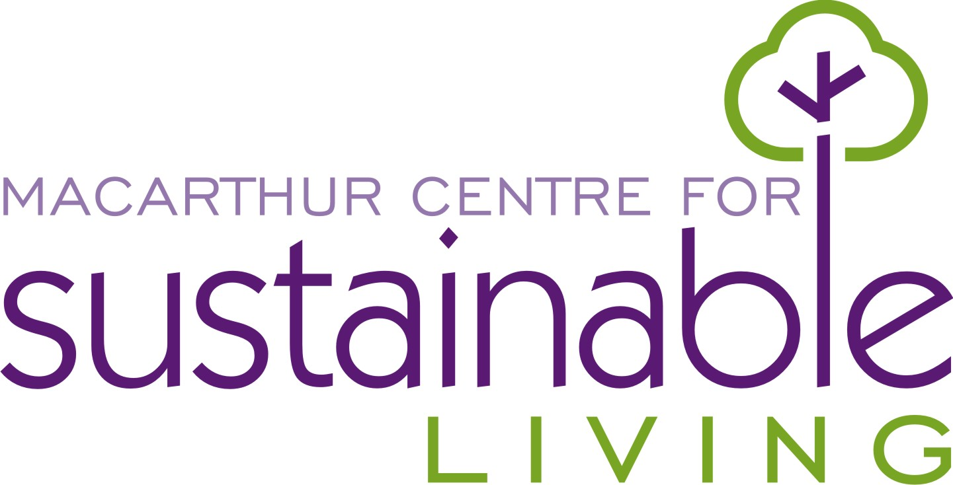

Contact Information
Name
Address |  |  |  |  | Postcode
Home Phone |  | Work Phone
Mobile |  | Email

Referred by________________________________________

Availability
When are you available for volunteer activities?

Monday am/pm | Friday am/pm
Tuesday am/pm
Wednesday am/pm
Thursday am/pm

What Language is spoken at Home_________________________________

Disabilities ______ Yes ______ NO

Are you of Aboriginal or Torres Straight decent _______Yes ______No

Interests
Tell us in which areas you are interested in volunteering.

Gardens
Events (markets, festivals, open days)
Building and construction

Other (please specify)

Special Skills or Qualifications
Summarise special skills and qualifications you have acquired from employment, previous volunteer work, or through other activities, including hobbies or sports.

Previous Volunteer Experience
Summarise any previous volunteer experience. (Previous experience is not necessary)

Medical Conditions and Injuries
List any medical conditions or injuries that we should be aware of:

Person to Notify in Case of Emergency
Name
Home Phone |  | Mobile
Work Phone

Age
Please indicate your age bracket by ticking one of the boxes below.
 | 16 – 80 years |  | 80+ years
Under 16 years*
*Children under 16 years of age must be in the care and under the supervision of an adult during all volunteer activities

Agreement and Signature
By submitting this application, I affirm that the facts set forth in it are true and complete. I understand that if I am accepted as a volunteer, I agree to accept the policies of the Centre and comply with the requirements of the Centre and its staff. This means I have read and will adhere to all Standard Operating Procedures and report any incident to a supervisor. Code of Conduct/WH&S is given to each volunteer and read through by a centre representative.

Name (printed)
Signature
Date

Our Policy
It is the policy of the Macarthur Centre for Sustainable Living to provide equal opportunities without regard to race, colour, religion, national origin, gender, sexual preference, age, or disability.

Thank you for completing this application form and for your interest in volunteering with us.

